Streamlining IT Procurement: Automating Standard Laptop Orders with Flow Designer

Team leader | Santhiya A
Team members | Mukila S  Pavithra L  Ramya Mari  Saranya D
Team id | 6ab1d5ff53fb8f5d0740195d
College code | ALUAU15

Problem Statement:
The Standard Laptop procurement process involves manual task creation and assignment after approval. This can cause delays and errors. The project aims to automate this process using ServiceNow Flow Designer, which creates a Catalog Task and assigns it to the Hardware team after approval.
The Service Catalog allows users to submit Standard Laptop requests, which are automatically processed once approved.

User Story:
As an IT procurement or Hardware team member,I want to order a Standard Laptop through the Service Catalog, so that my laptop request can be submitted for approval and, once approved, the required Catalog Task is automatically created and assigned to the Hardware team for configuration.so, that laptop requests can be processed quickly and without manual intervention.

Acceptance Criteria
- User can select and order the Standard Laptop through the Service Catalog.
- The submitted request goes through the approval process.
- Once approved, a Catalog Task is automatically created.
- The task is linked to the related Requested Item.
- The task is automatically assigned to the Hardware team.
- The complete process is verified using a test laptop order.

Project Objective:
The main objective of this project is to automate the Standard Laptop procurement process using ServiceNow Flow Designer. The automation is designed to reduce manual effort, improve processing efficiency, and ensure that approved laptop requests are properly assigned to the Hardware team:

- Automate Catalog Task creation.
- Automatically assign tasks to the Hardware team.
- Reduce manual work and errors.
- Improve processing speed and task visibility.
- Ensure consistent handling of Standard Laptop requests.
- Streamline the Service Catalog procurement process.

Tools and Technology Used

1. Platform: ServiceNow

2. Core Modules:
- Service Catalog: To allow users to order Standard Laptop through self-service portal.
- Flow Designer: Main automation tool to automatically create Catalog Task after approval.
- Process Engine & Maintain Items: To map the created Flow to the Standard Laptop Catalog Item.
- Request Management: To manage REQ, RITM, and SCTASK life-cycle.

3. Flow Designer Actions Used:
- Trigger: Service Catalog - Trigger when Request is approved.
- Action: Create Catalog Task - To create Hardware task with short description "Laptop need to Configured".
- Configuration: Assignment Group = Hardware, Approval = Approved, Request Item = Trigger Record.

System Architecture & Workflow

The system automates the IT procurement process from request to task assignment.

Workflow Sequence:
1. User Request: User -> Service Catalog -> Hardware -> Standard Laptop -> Click Order Now. System creates Request (REQ) and Requested Item (RITM).

2. Approval Process: RITM is sent to Approver. Approver opens RITM -> Approvers tab -> Clicks Approve.

3. Flow Trigger: The approval triggers the Flow Designer Flow named "Standard laptop task". Run as System User, Application Global.

4. Automated Action: Flow executes Action "Create Catalog Task" with details:
- Request Item = RITM Record
- Table = Catalog Task (sc_task)
- Short Description = Laptop need to Configured
- Assignment Group = Hardware

5. Completion & Verification: A new SCTASK is created and assigned to Hardware team. Team verifies task in RITM -> Catalog Tasks related list.

Final Flow Diagram:
User -> Service Catalog Order -> Approval -> Flow Designer (Service Catalog Trigger) -> Create Catalog Task Action -> Hardware Assignment -> Verification

TASK INITIATION

Milestone 1 : Flow

Activity 1 : Create a Flow to Create Catalog task to update the short description after Approval the service Request and it will be Assignment group to Hardware.
- Open service now.
- Click on All >> search for Flow Designer
- Click on Flow Designer under Process Automation.
- After opening Flow Designer Click on new and select Flow.
- Under Flow properties Give Flow Name as “ Standard laptop task”.
- Application should be Global.
- Select Run user as “ System user ” from that choice.
- Click on Submit.
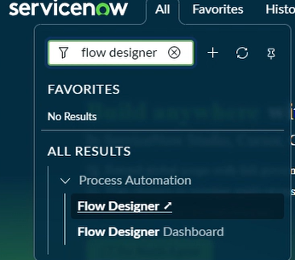

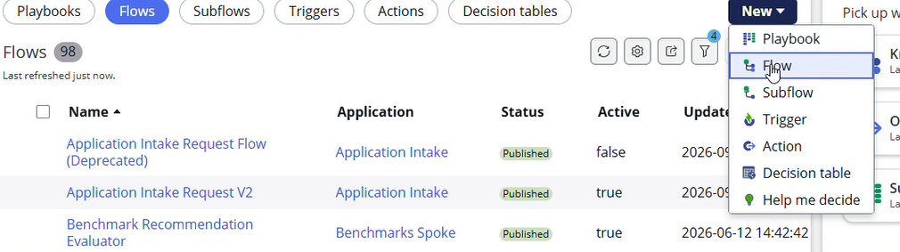

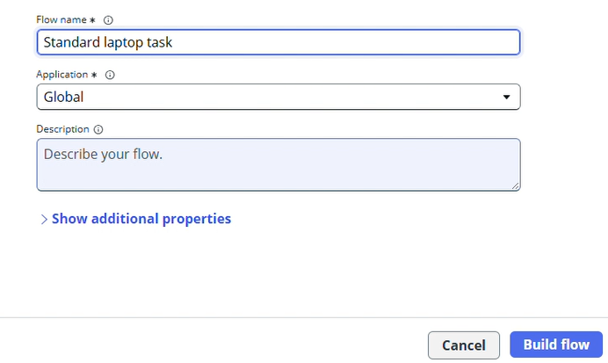

9.Click on Add a trigger
10.Select the trigger in that Search for “ Service Catalog ” and select that.
11.After that click on Done.
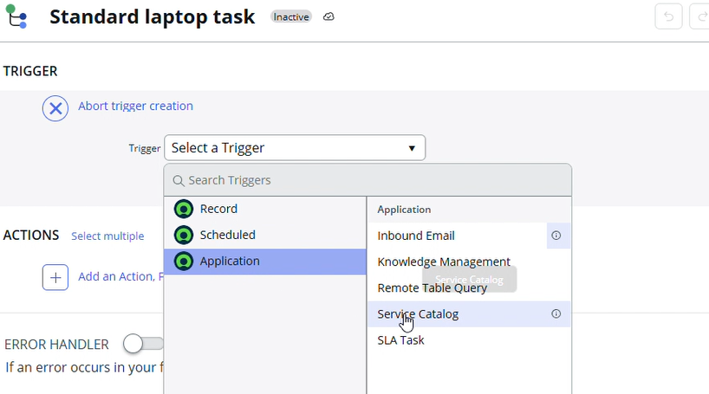

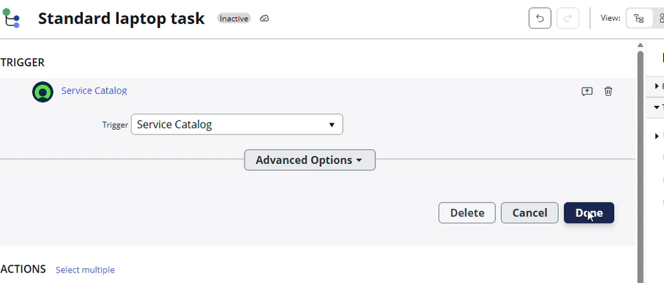

12. Now under Actions.
13. Click on Add an action.
14. Select action in that search for “ Create Catalog Task ” and select that.
15. Mention these in that action
16. Action as Create Catalog Task
17. Drag and drop the Requested Item Record in the Request item.
18. Table will be auto populated as a Catalog Task.
19. Mention the short description as “ Laptop need to Configured ”.
20. Click on add field value
21. Select description field and value as “ Laptop need to Configured ”.
22. Select Assignment group field and value as “ Hardware ”.
23. Select Approval field and value as “ Approved ”.
24. Leave the remaining as default and click on Done.
25. Click on save the Flow.
26. And Click on Activate again click on Activate.

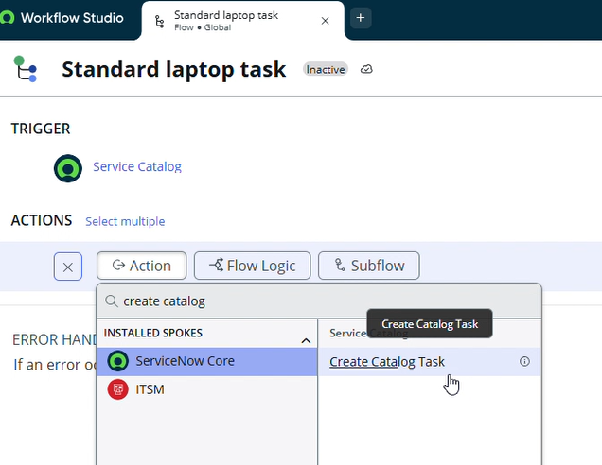

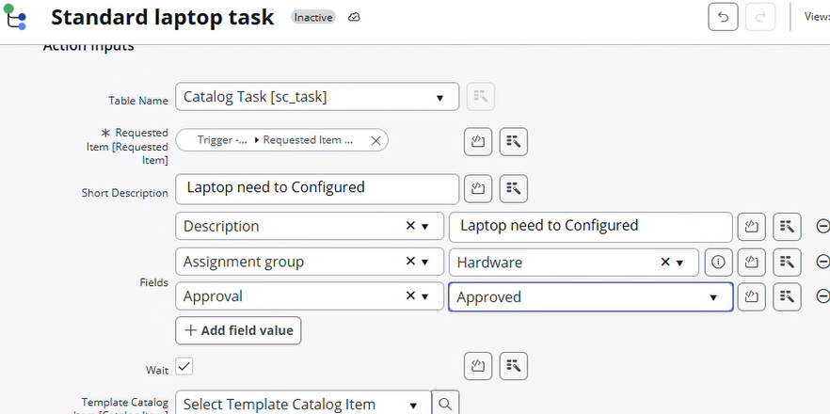
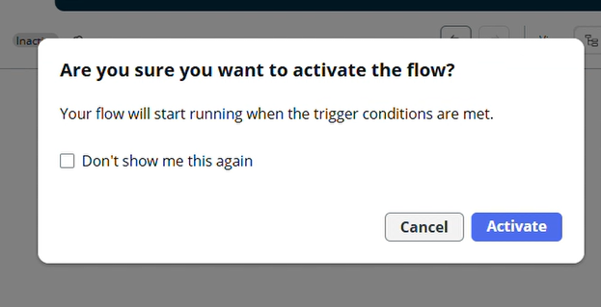

Milestone 2 : Flow assignment

Activity 1 : Flow Assignment to Standard laptop service Catalog.

- Open ServiceNow.
- Click on all search for Maintain Items.
- Select Maintain Items.
- Under the name field search for Standard Laptop Select that record.
- Under that record select Process engine
- Remove the remaining automations and add Flow.
- Add the flow that was created with the name “ Standard Laptop Task”.
- Click on the menu to save the record.

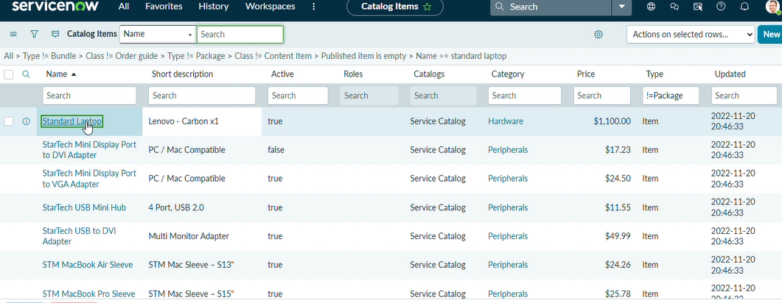

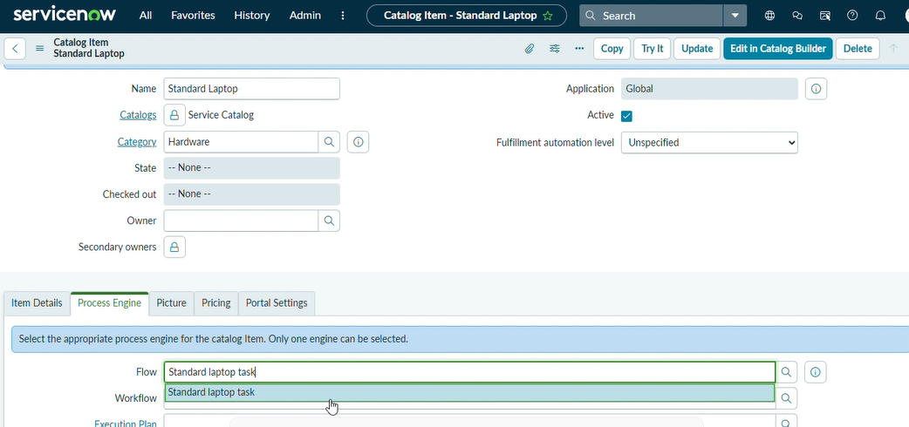

Milestone 3 : Service Catalog

Activity 1: Service Catalog for placing order and get Approval

- Click on All >> Search for “ Service Catalog ”.
- Click on Service Catalog >> click on Hardware.
- Scroll a bit to find the “ Standard Laptop ” click on that.
- After that click on “ Order Now ” to place the request.
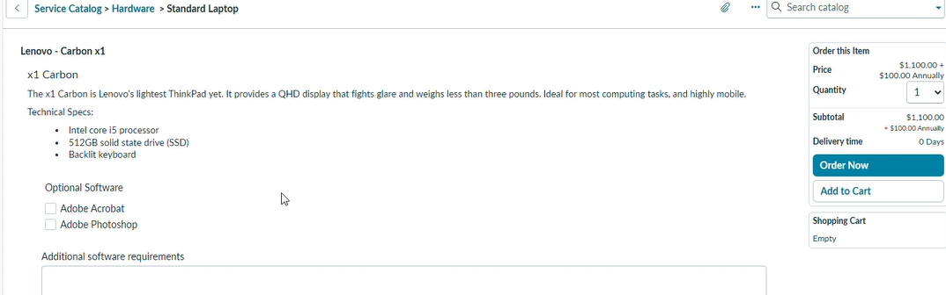

- Now we will see the Order status
- In that click on the Request Number

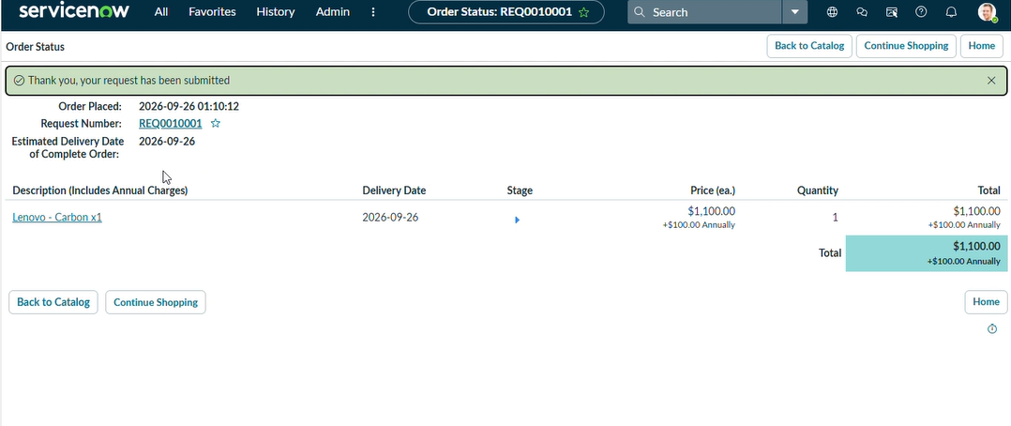
- It will open the Requested number record.
- Scroll down Click on the Approvers Section.
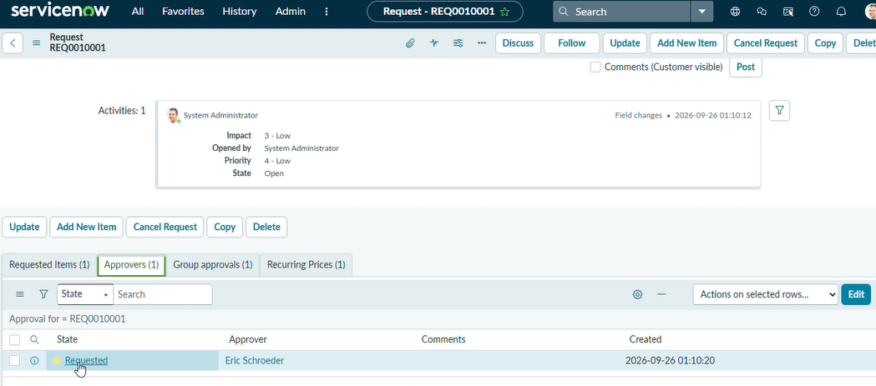
- Right Click on the Record to see config in that Click on the Approve.
- Then click on the Requested item Section
- Open that Requested Item record
- Scroll down to the “ Catalog tasks ” Section
13. Open the record to see the updated status of the record with Short description and Assigned group.
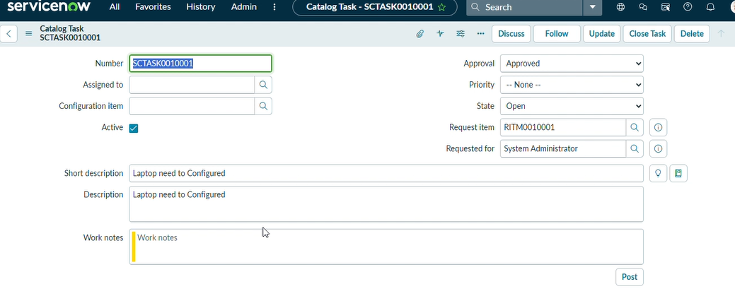

Conclusion :
The Standard Laptop Task Automation simplifies the IT procurement process by using ServiceNow Flow Designer. It automatically creates and assigns tasks after approval,reducing manual effort,improving efficiency,and ensuring that approved laptop requests are processed consistently.

